<https://www.youtube.com/watch?v=7xHsRkOdVwo&list=PLblh5JKOoLUICTaGLRoHQDuF_7q2GfuJF&index=33>

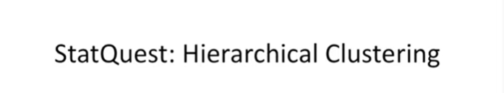

Today we're going to be talking about hierarchical clustering.



Hierarchical clustering is often associated with heat maps.

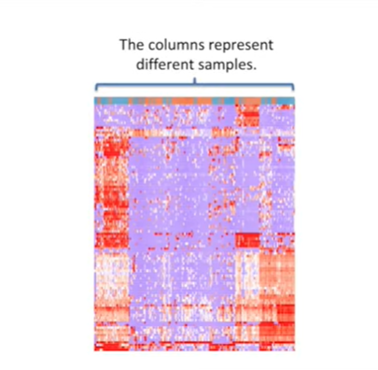

If you're not already familiar with what heat maps are just know that the columns typically represent different samples

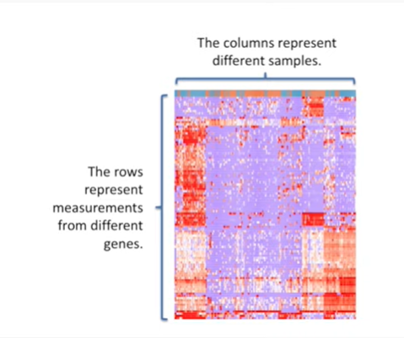

and that the rows typically represent measurements from different genes.

Red typically signifies high expression of a gene and blue or purple means lower expression for a gene.

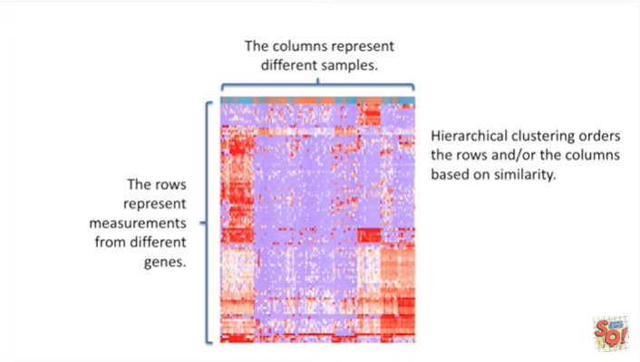

Hierarchical clustering orders the rows and or the columns based on similarity.

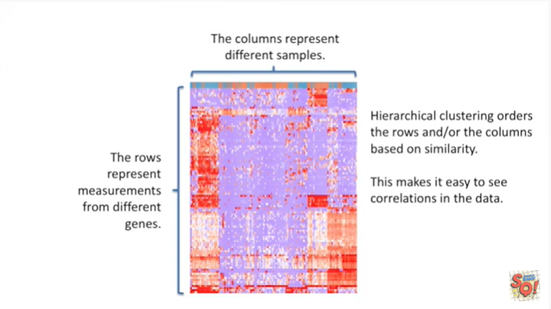

This makes it easy to see correlations in the data.

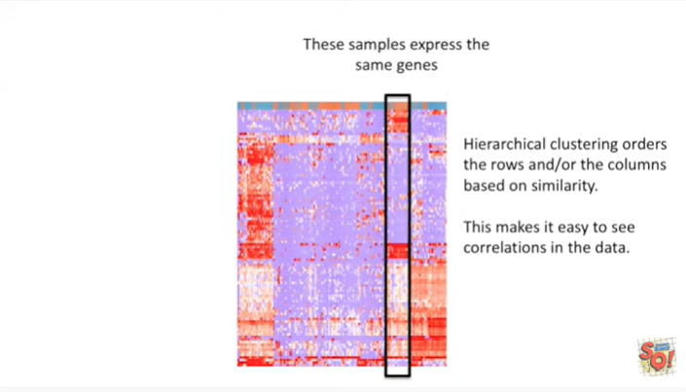

For example these samples express the same genes.

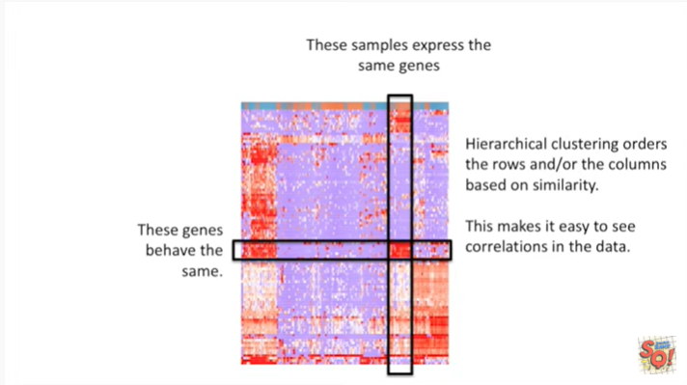

And these genes behave the same.

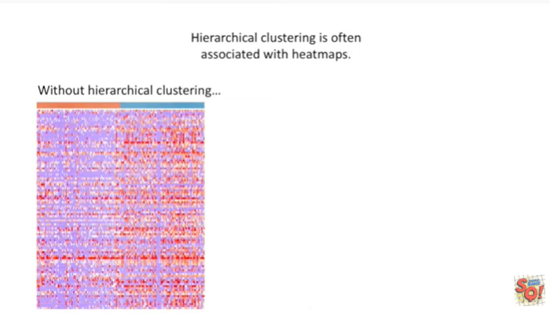

On the Left we have a heat map without hierarchical clustering

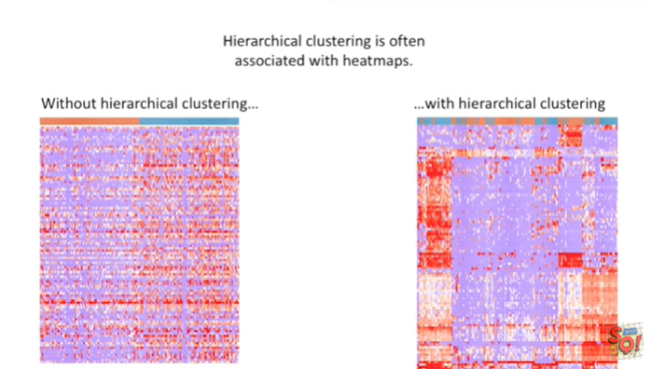

and on the right we have a heat map with hierarchical clustering.

So you can see that the clustering makes a big difference on how the data is presented.

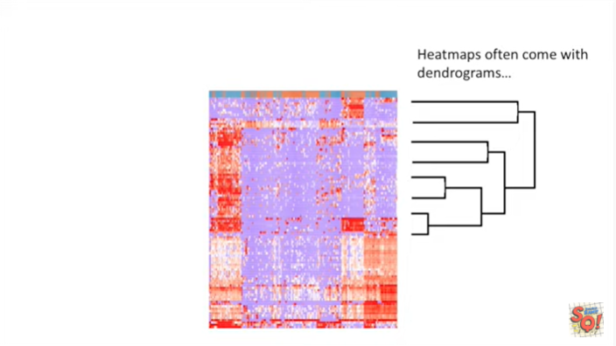

Heat maps often come with dendrograms.

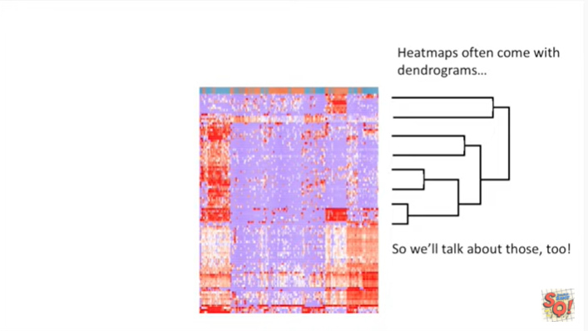

So we'll talk about those too.

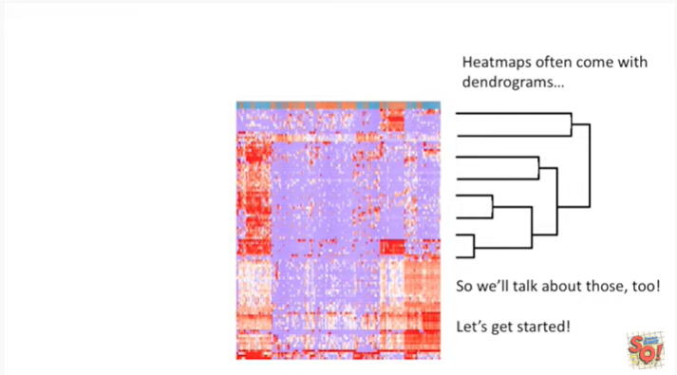

Let's get started.

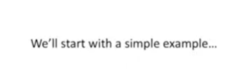

We'll start with a simple.

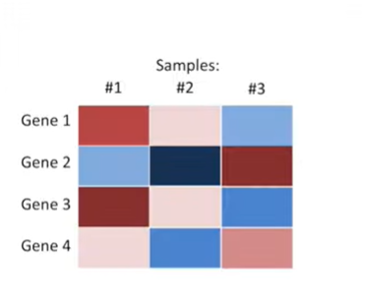

Example here we've got a simple heat map that has three samples and four genes.

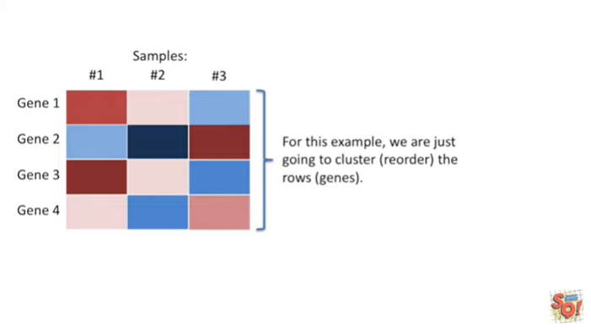

For this example we are just going to cluster or reorder the rows or the genes.

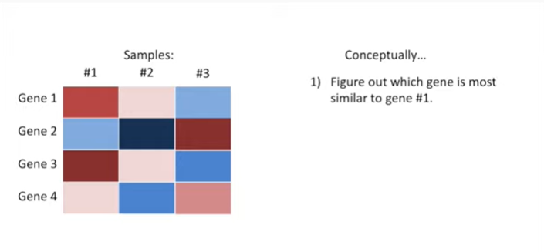

Conceptually the first step is to figure out which gene is most similar to gene number one.

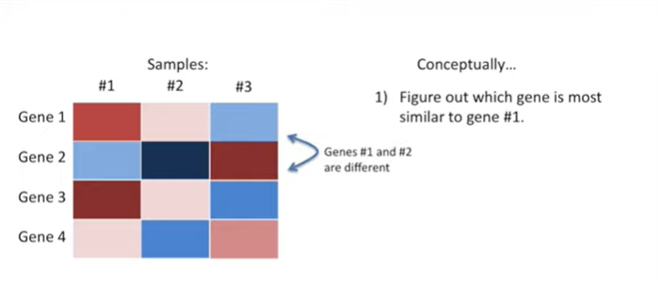

Genes number one and two are different.

We can tell because the colors are very different.

Gene one is highly expressed on sample number one, so it has a red color.

Gene two, however, is not highly expressed on sample number one so it has a blue color.

In sample number three gene one is lowly expressed, so it's blue.

Aand gene two is highly expressed, so it's red.

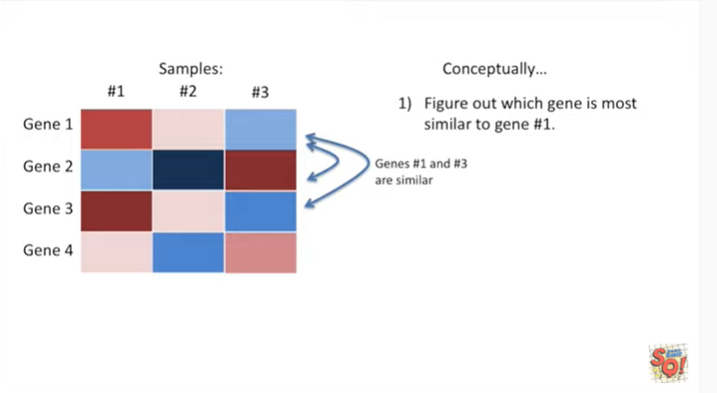

Genes one and three are similar.

So that means in sample one both gene one and three are red, they're highly expressed.

And in sample three they're both blue, meaning they're lowly expressed.

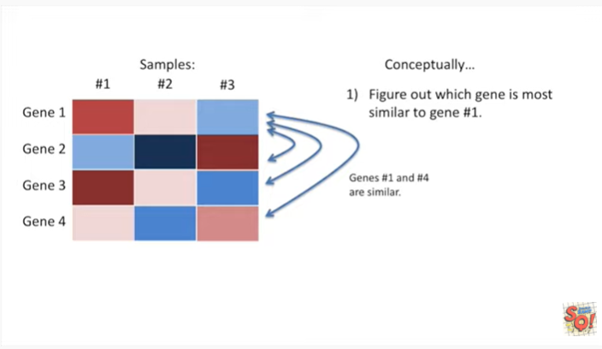

Genes one and four are also similar.

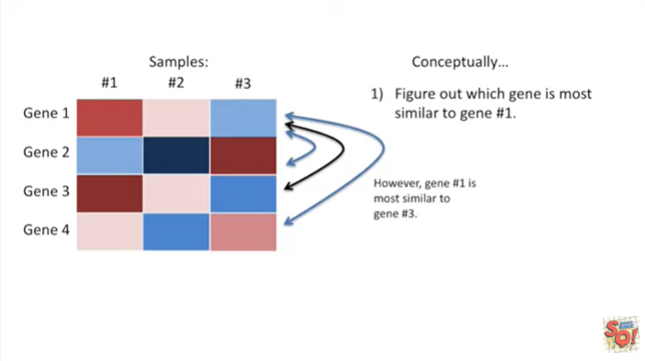

However gene number one is most similar to gene number three.

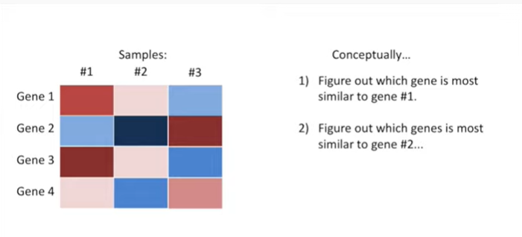

So the second step is to figure out what gene is most similar to gene number two.

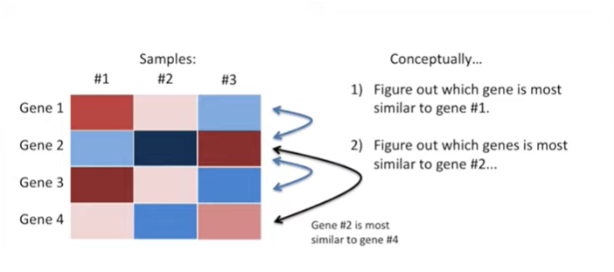

So we do all the comparisons and we see that gene number two is most similar to gene number four.

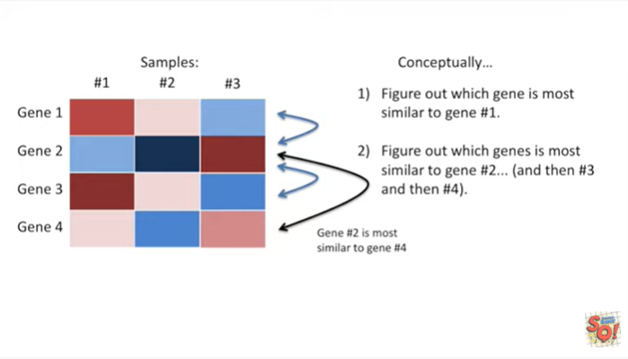

And then we do the same thing for gene number three and then gene number four.

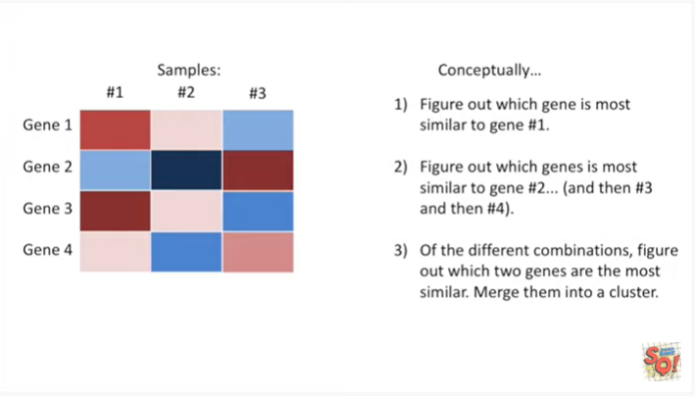

In step number three, we look at the different combinations and figure out which two jeans are the most similar.

Once we've done that we merge them into a cluster.

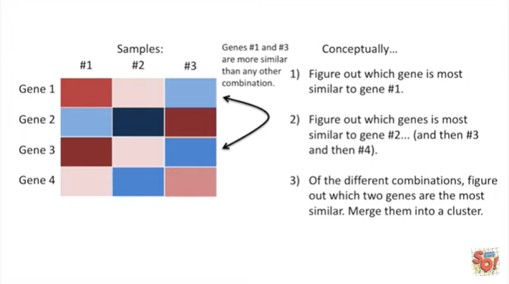

In this case jeans number one and three are more similar than any other combination of genes.

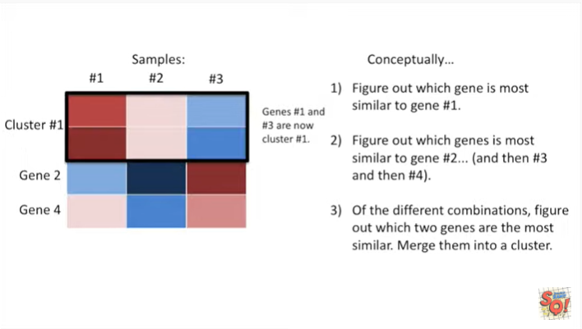

So genes one and three are now cluster number one.

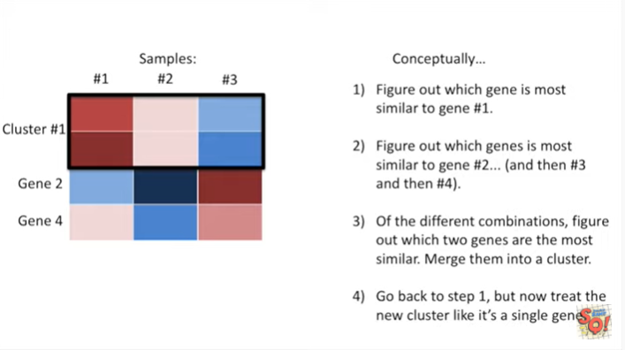

Step four go back to step one but now treat the new cluster like it's a single gene.

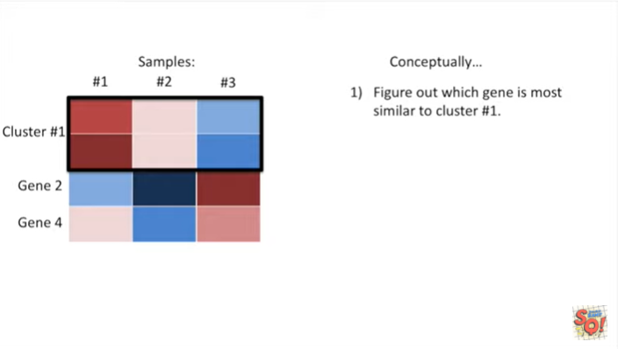

So in step one, we figure out which gene is most similar to cluster number one.

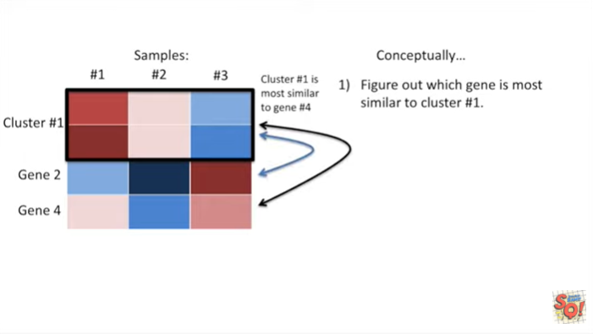

Cluster number one is most similar to gene number four.

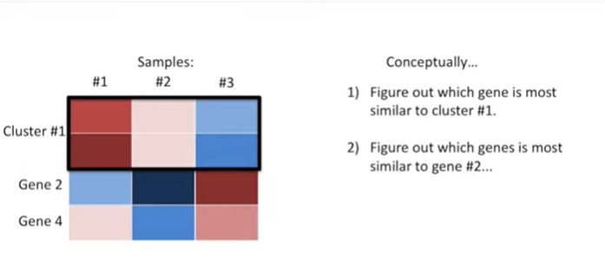

And we figure out which gene is most similar to gene number two.

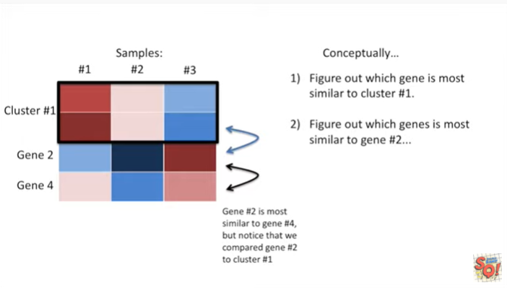

In this case gene number two is most similar to gene number four, but notice that we compared gene number two to cluster number one.

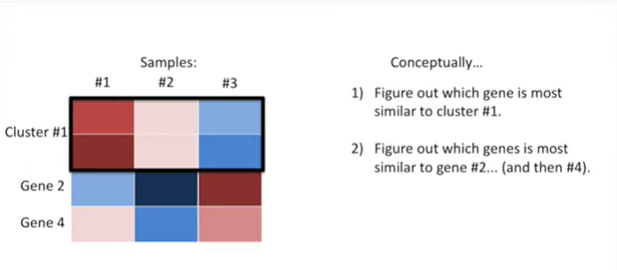

And then we do the same thing for game number four.

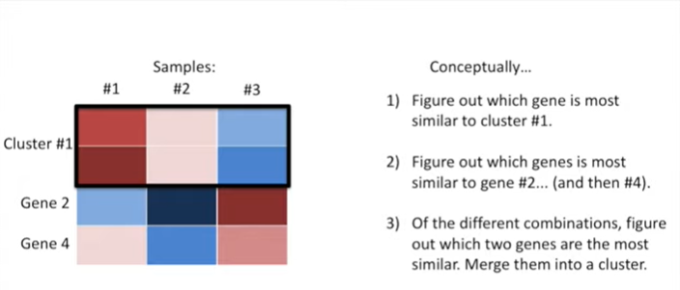

Of the different combinations figure out which two genes are the most similar.

Now merge them into a cluster.

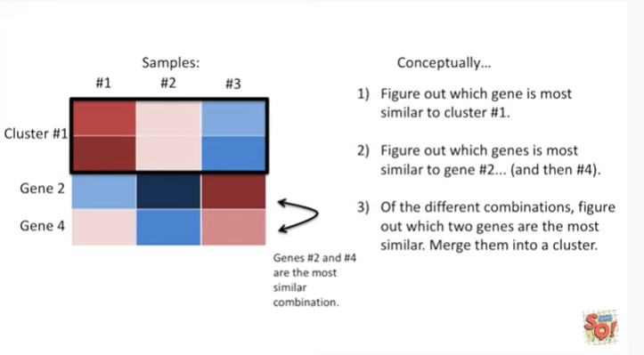

In this case genes two and four are the most similar combination, so we've merged them into a cluster.

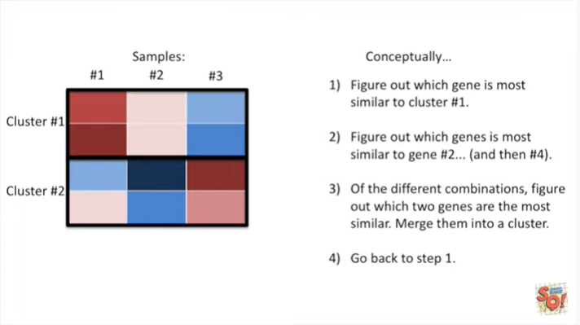

Now we go back to step one.

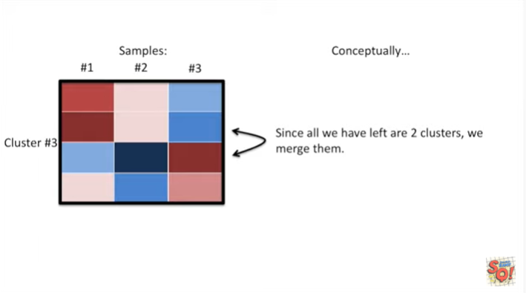

However since all we have left are two clusters we merge them.

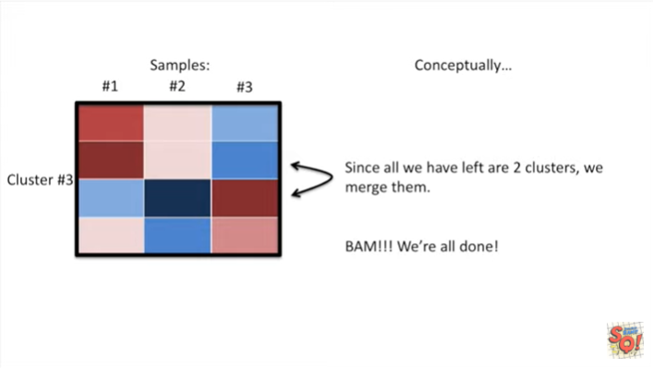

BAM !!

We're all done.

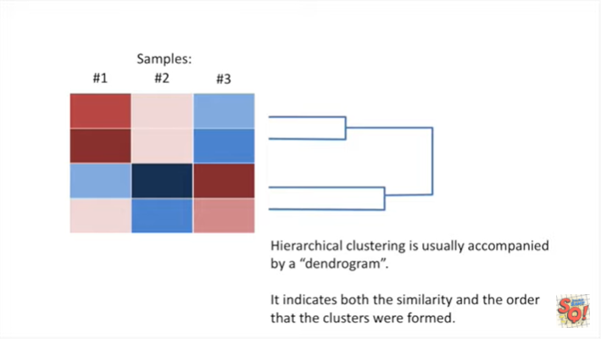

Hierarchical clustering is usually accompanied by a dendrogram.

It indicates both the similarity and the order that the clusters were formed.

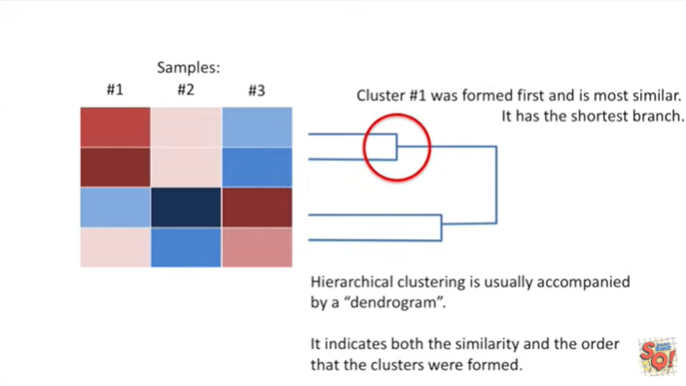

Cluster number one was formed first and is most similar.

It has the shortest branch.

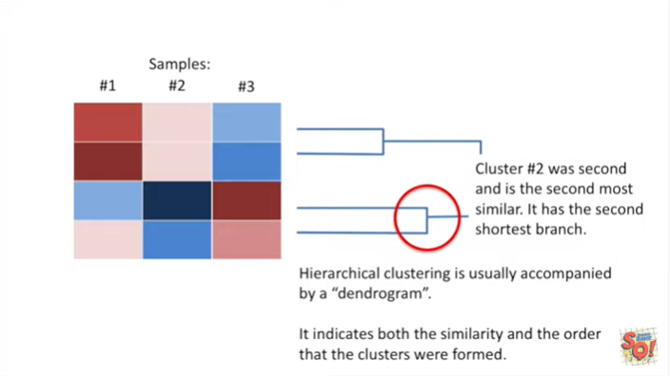

Cluster number two was second and is the second most similar.

It has the second shortest branch.

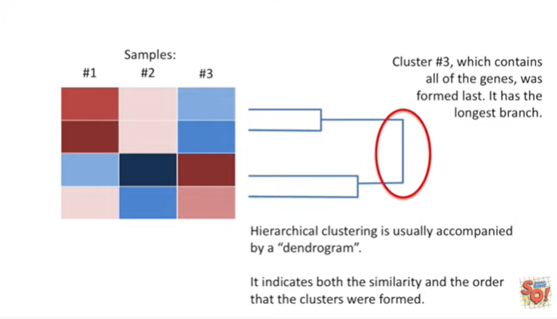

Cluster number three which contains all of the genes was formed last.

It has the longest branch.



Now let's go over a few nitpicky details.

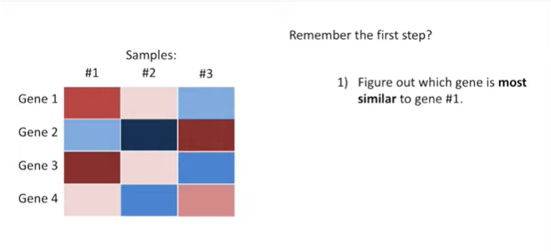

Remember the first step figure out which gene is most similar to gene number one.

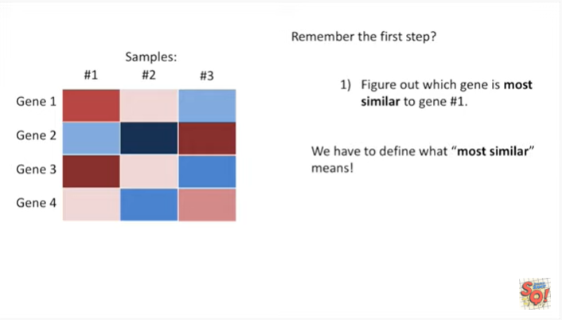

Well we have to define what most similar means !!

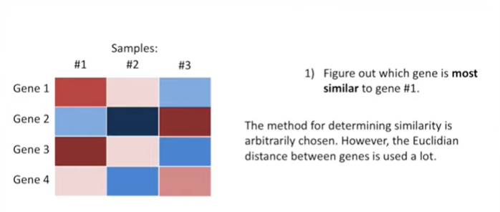

The method for determining similarity is arbitrarily chosen however the Euclidean distance between genes is used a lot.

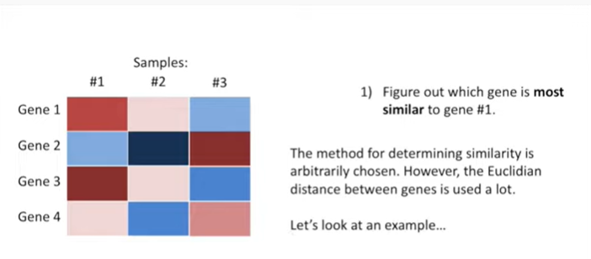

Let's look at an example.

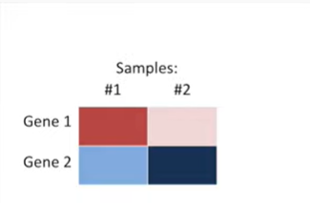

We'll use a very simple heat map that just has two samples and two genes.

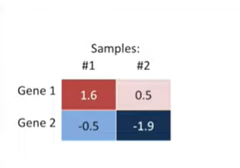

Now we're displaying the values that underlie the colors that we have in the heat map.

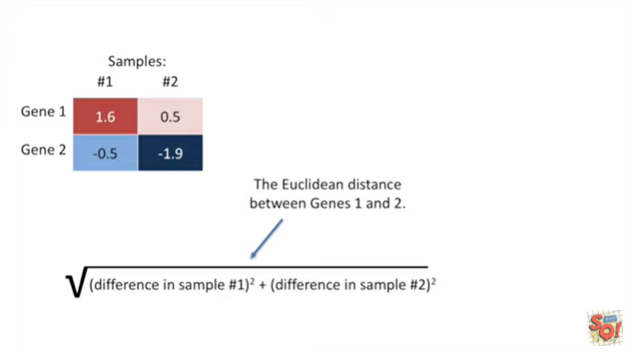

The Euclidean distance between genes 1 & 2 is just the square root of the difference in sample number one squared plus the difference in samplenumber two squared.

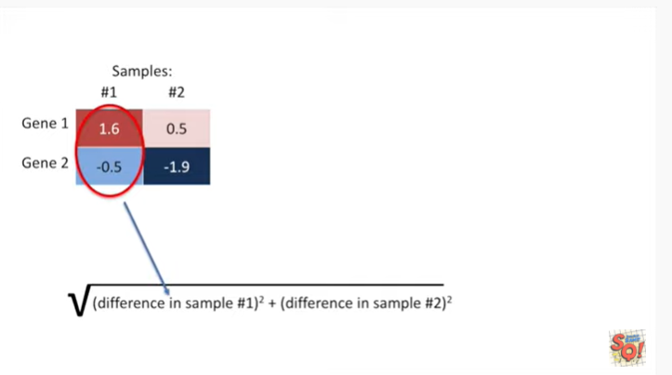

Here we'll just plug in the values for sample number one.

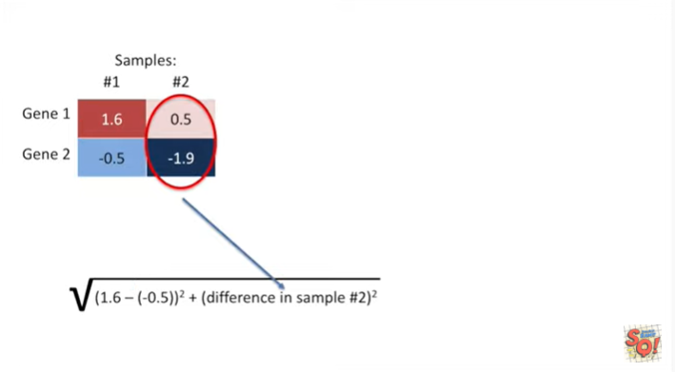

We have one point six minus negative zero point five.

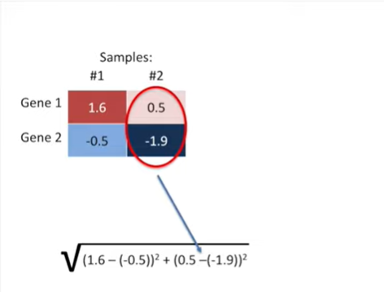

Now let's plug in the values to calculate the difference in sample number two.

We have zero point five minus negative one point nine.

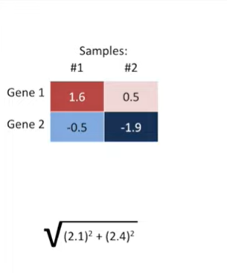

Doing the subtraction gives us the square root of two point one squared plus two point four squared.

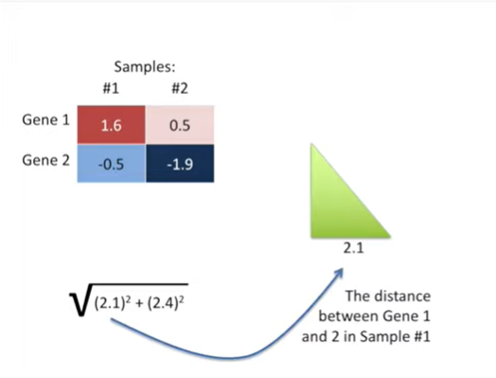

We can think of these values within the parentheses as sides on a triangle.

So on the x-axis we have the distance between gene one and gene two in sample number one.

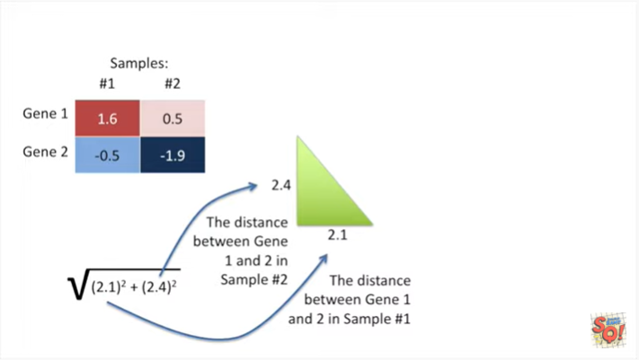

And on the y-axis we have the distance between gene one and two in sample number two.

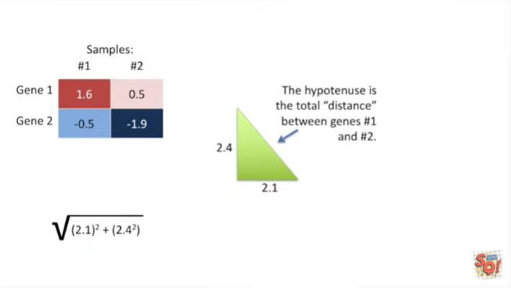

The hypotenuse is the distance between genes one and two.

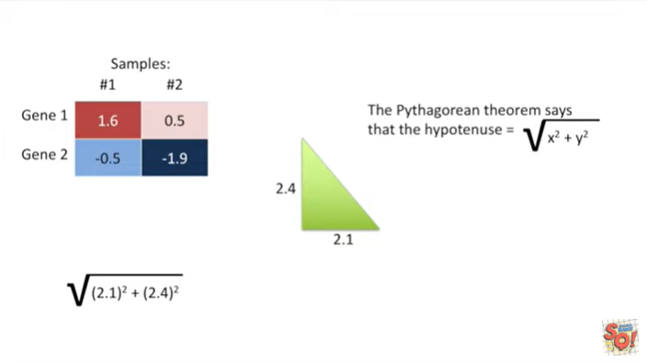

The Pythagorean theorem says the hypotenuse equals the square root of x squared plus y squared.

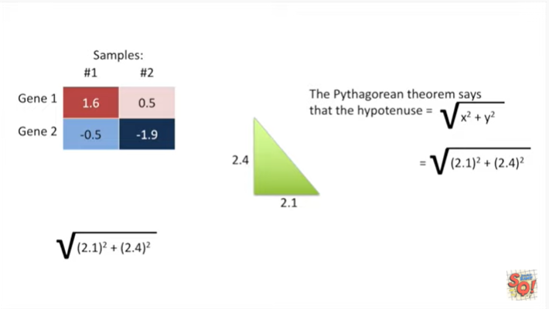

In this case that means the square root of two point one squared plus two point four squared.

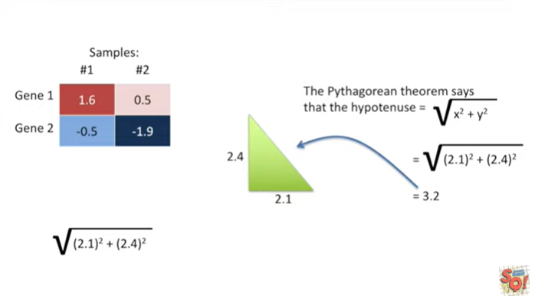

And that gives us three point two the distance between gene number one and gene number two.

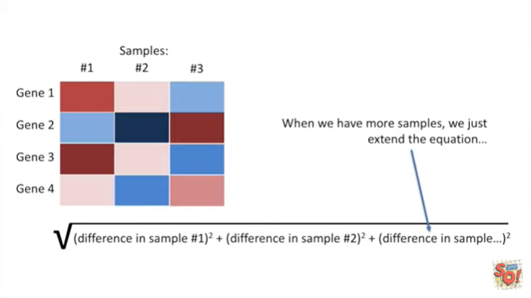

When we have more samples we just extend the equation.

Tt's no big deal !

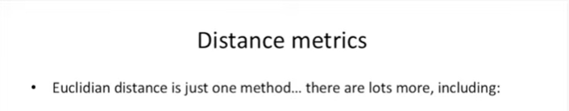

Euclidean distance is just one method.

There are lots more including :

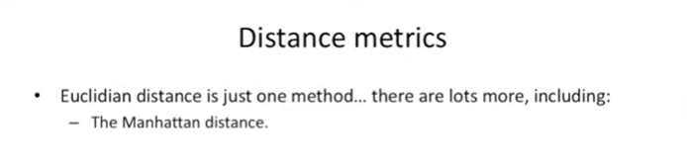

- the Manhattan distance.

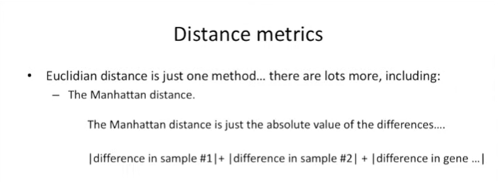

The Manhattan distance is just the absolute value of the differences.

So instead of squaring the differences and then taking the square root, all we do is take the absolute value of the differences.

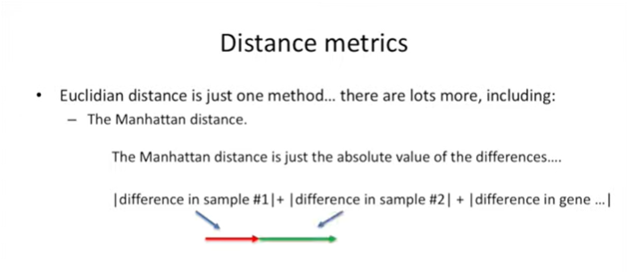

We can think of the Manhattan distance in geometric terms by imagining that each difference is a line segment.

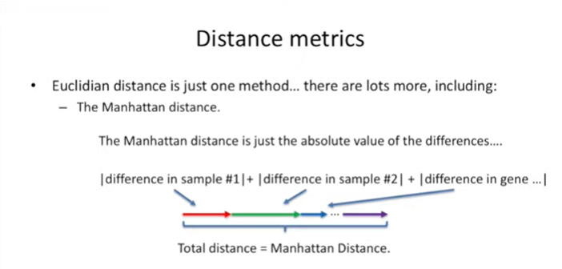

If we take all those line segments and put them together, head to tail, head to tail and then add.

That total length of all those line segments together, that's the Manhattan distance.

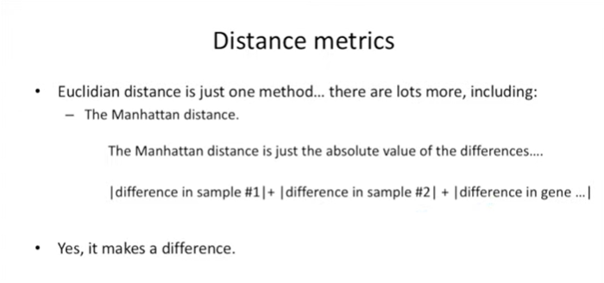

Yes it makes a difference.

Wah, wahh.

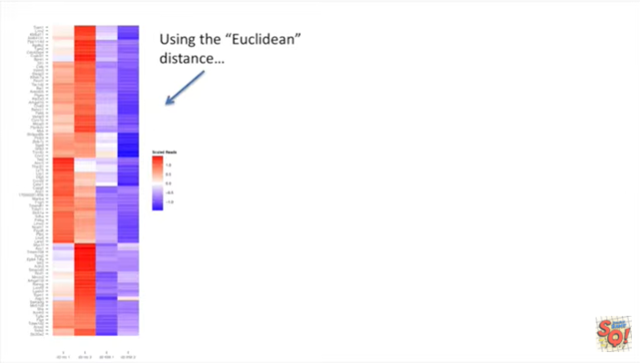

Here's a heat map drawn using the Euclidean distance

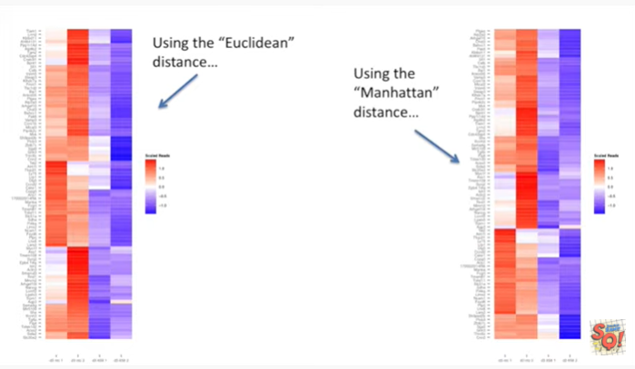

and here's the same information drawn as a heat map, but now we're using the Manhattan distance.

The heat maps are very similar but there are also a few differences.

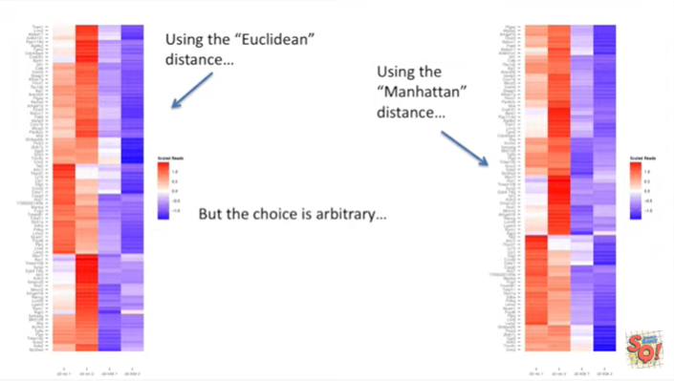

But the choice and distance metric is arbitrary.

Wah, wahh.

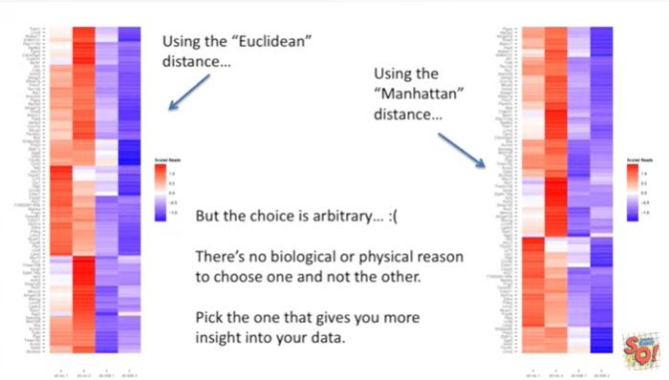

There's no biological or physical reason to choose one and not the other.

Pick the one that gives you more insight into your data.

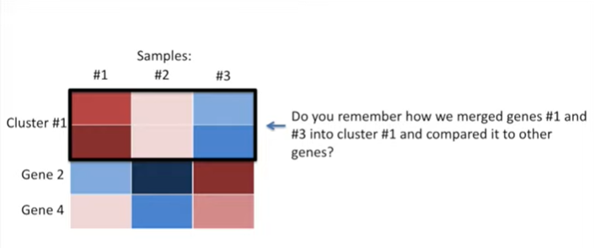

Now do you remember how we merged genes 1 and 3 into cluster number one and compared it to other genes.

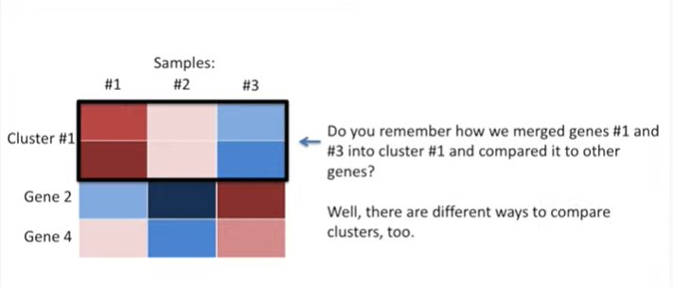

Well there are different ways to compare clusters, too.

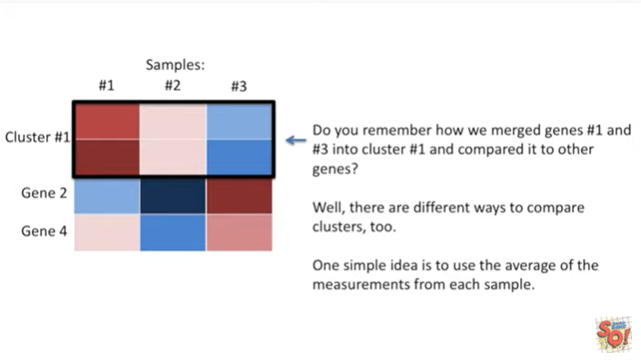

One simple idea is to use the average of the measurements from each sample.

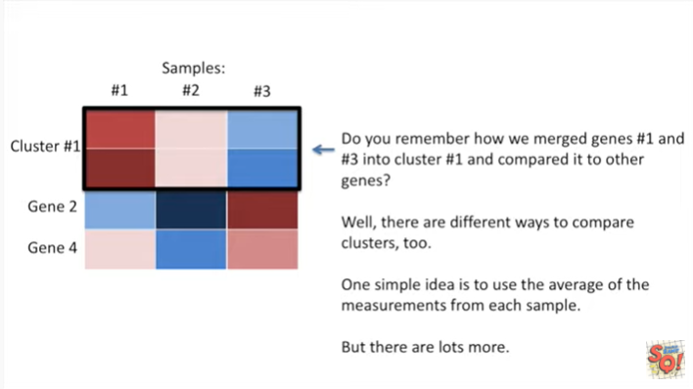

But there are lots more.

And these have effect on clustering as well.

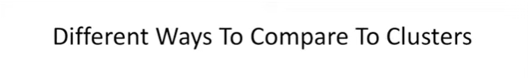

So let's talk about the different ways to compare clusters.

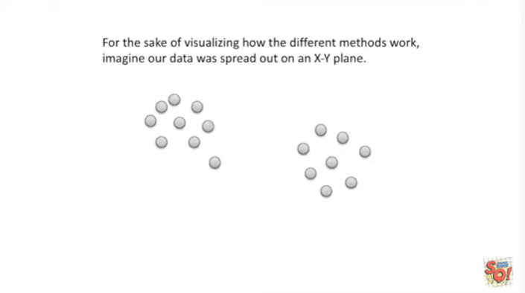

For the sake of visualizing how the different methods work, imagine our data was spread out on an X/Y plane.

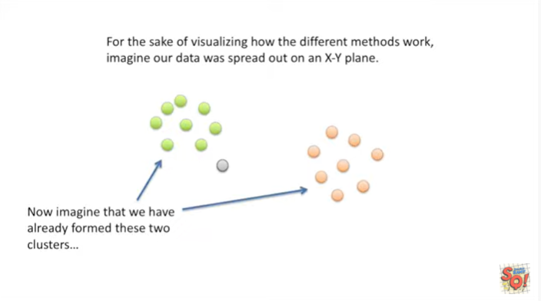

Now imagine that we have already formed these two clusters

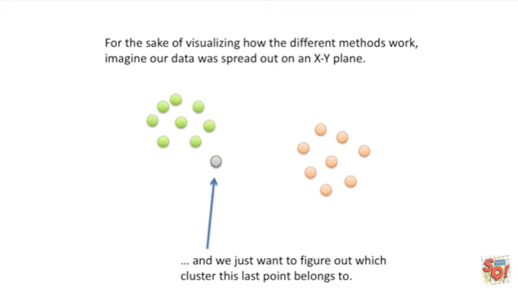

and we just want to figure out which cluster this last point belongs to.

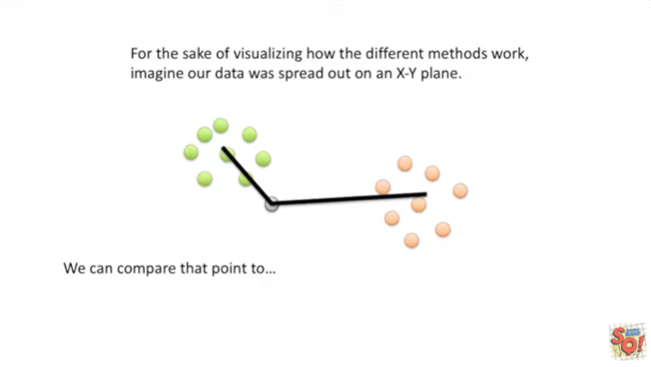

We can compare that point to :

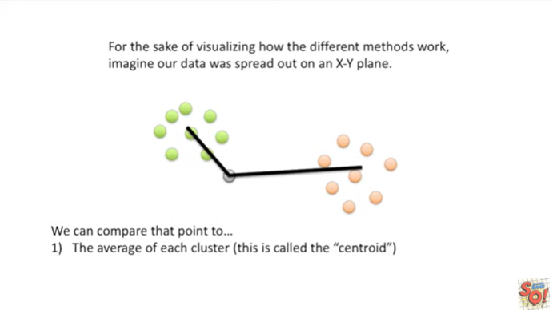

1. the average of each cluster (this is called the centroid.

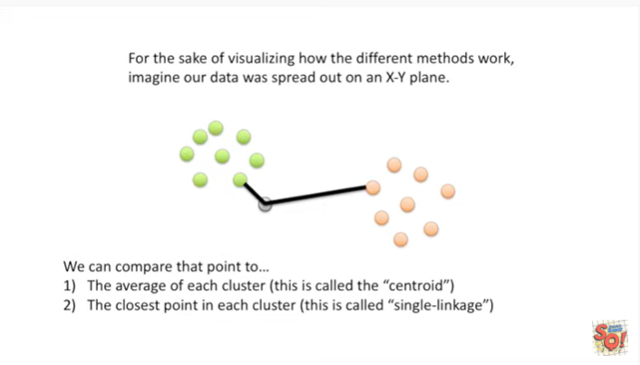

2. The closest point in each cluster (this is called single linkage).

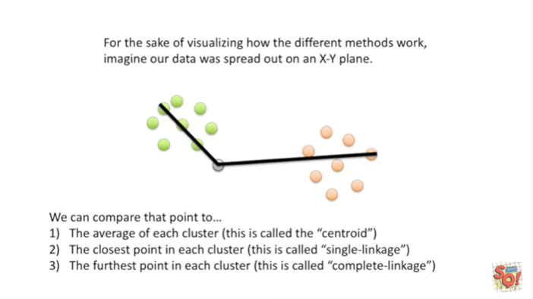

Or 3. we can compare it to the furthest point in each cluster (this is called complete linkage).

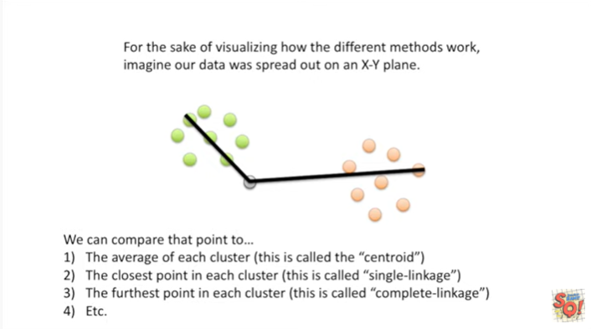

And there are other methods as well.

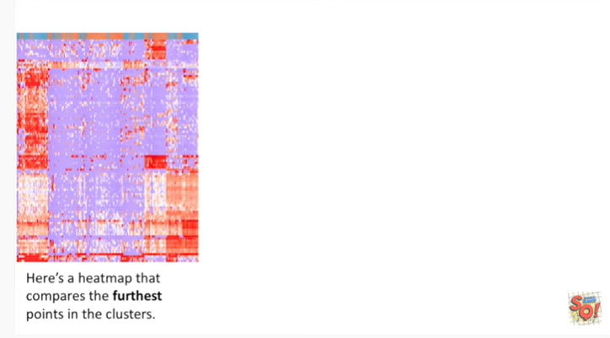

Here's a heat map that compares the furthest points in the clusters.

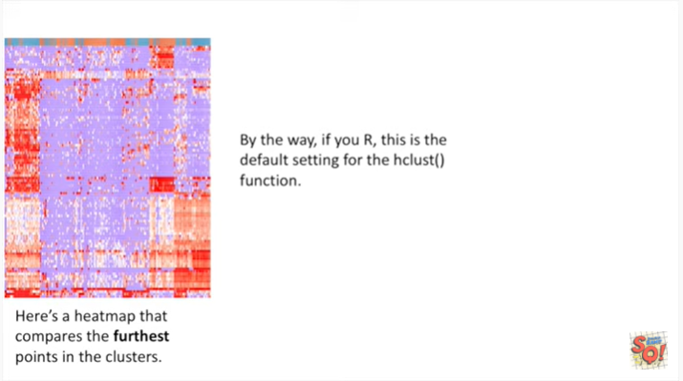

By the way if you use R, this is the default setting for the hclust() function.

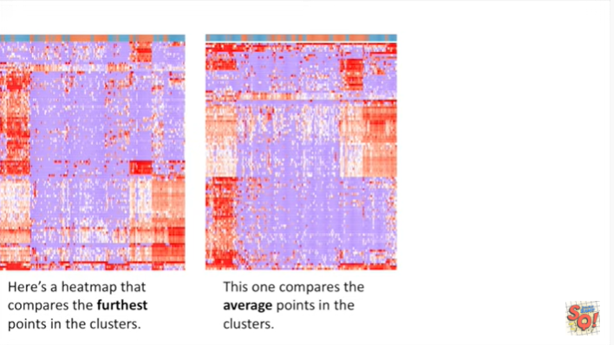

This heat map compares the average points in the clusters.

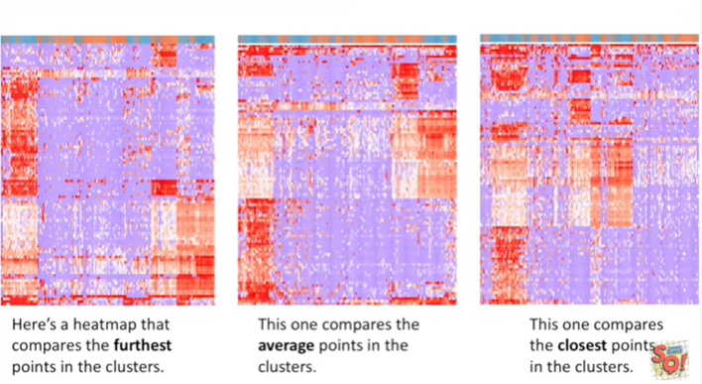

And this last heat map compares the closest point in the clusters.

These heat maps are all very similar but there are also differences in the way the data is presented.

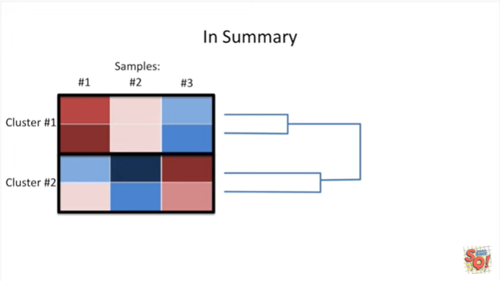

In summary :

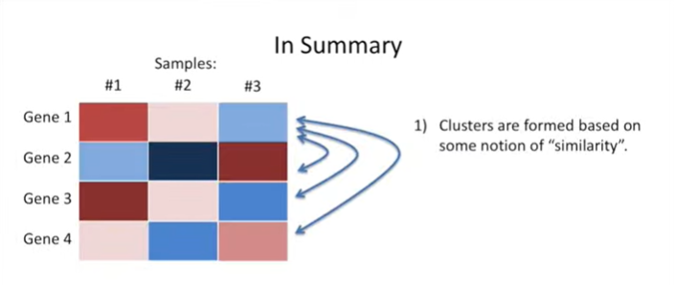

1. clusters are formed based on some notion of similarity.

You have to decide what that is.

However most programs have reasonable defaults.

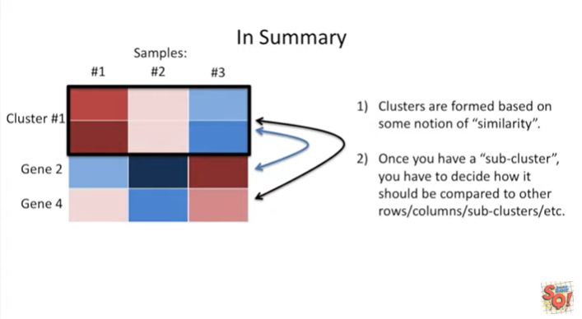

2. Once you have a sub cluster, you have to decide how it should be compared to other rows columns or sub clusters etc.

And most programs have good default settings for this as well.

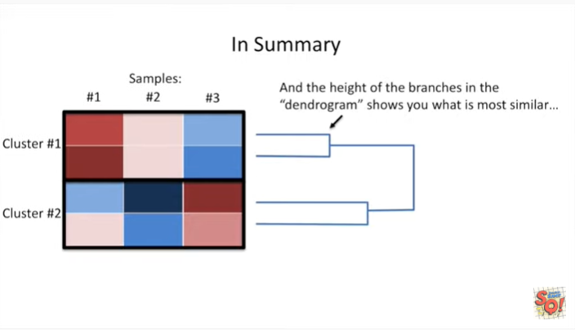

And the height of the branches in the dendrogram shows you what is most similar.